++Normalisation:

It is database design techniques which organised tables in such a manner that reduces the redundancy and dependency of data.

[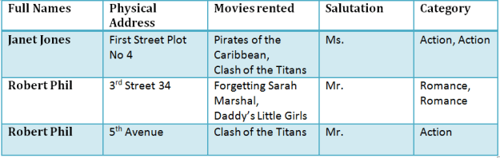](http://cdn.guru99.com/images/NormalizationTable1.png)

1NF:

-Each table cell contains single value.

-Each records needs to be unique.

[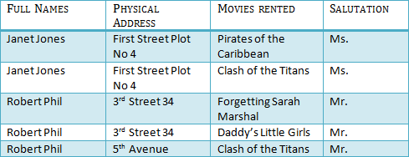](http://cdn.guru99.com/images/1NF.png)

2NF:

-Be in 1NF

-single column primary key.

- Assign Foreign Key also here

Primary Key:

A primary is a single column values used to uniquely identify a database record.

It has following attributes

A primary key cannot be NULL

A primary key value must be unique

The primary key values can not be changed

The primary key must be given a value when a new record is inserted.

Table 1: Contains Membership Information

[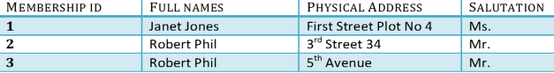](http://cdn.guru99.com/images/Table2.png)

Table 2: Contains information on movies rented

[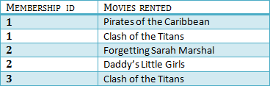](http://cdn.guru99.com/images/Table1.png)

**Foreign Key:**

Foreign Key references primary key of another Table! It helps connect your Tables

A foreign key can have a different name from its primary key

It ensures rows in one table have corresponding rows in another

Unlike Primary key they do not have to be unique. Most often they aren't

Foreign keys can be null even though primary keys can not

In Table 2 Membership_Id is a reference key.

Note

Functional Transitive Dependency: Transitive functional dependancy means when changing a not-key column, might cause any of other non-key column to change.

Consider Table 1 changing the non key column full name, may change salutation

[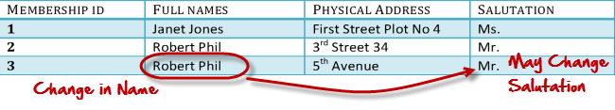](http://cdn.guru99.com/images/transitive_functional_dependencies.png)

3NF:

- Must be in 2NF.

- Has no transitive functional dependancy.11

Table 1

[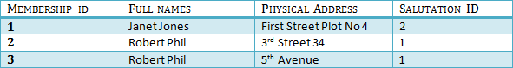](http://cdn.guru99.com/images/2NFTable1.png)

Table 2

[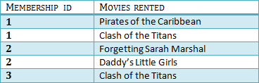](http://cdn.guru99.com/images/2NFTable2.png)

Table 3

[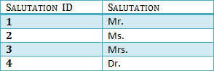](http://cdn.guru99.com/images/2NFTable3.png)

We have again divided our tables and created a new table which stores Salutations.

There are no transitive functional dependencies and hence our table is in 3NF

In Table 3 Salutation ID is primary key and in Table 1 Salutation ID is foreign to primary key in Table 3.

**Boyce Codd Normal Form (BCNF)**

Even when a database is in 3rd Normal Form, still there would be anomalies resulted if it has more than one **Candidate**Key.

Sometimes is BCNF is also referred as .**3.5 Normal Form.**